Sample PHP application Fixes and Debug Joslen Tardencilla

COP2842

Chapter 11: How to create and use arrays.

1. Run the application.Graphical user interface, text, application

   Description automatically generated
2. Test this application by using the add task button to enter three tasks and the delete task button to delete one of the tasks. These buttons should work as described in the text.Graphical user interface, application

   Description automatically generatedGraphical user interface, application

   Description automatically generated
3. Open the index. PHP and task list. PHP files for this application.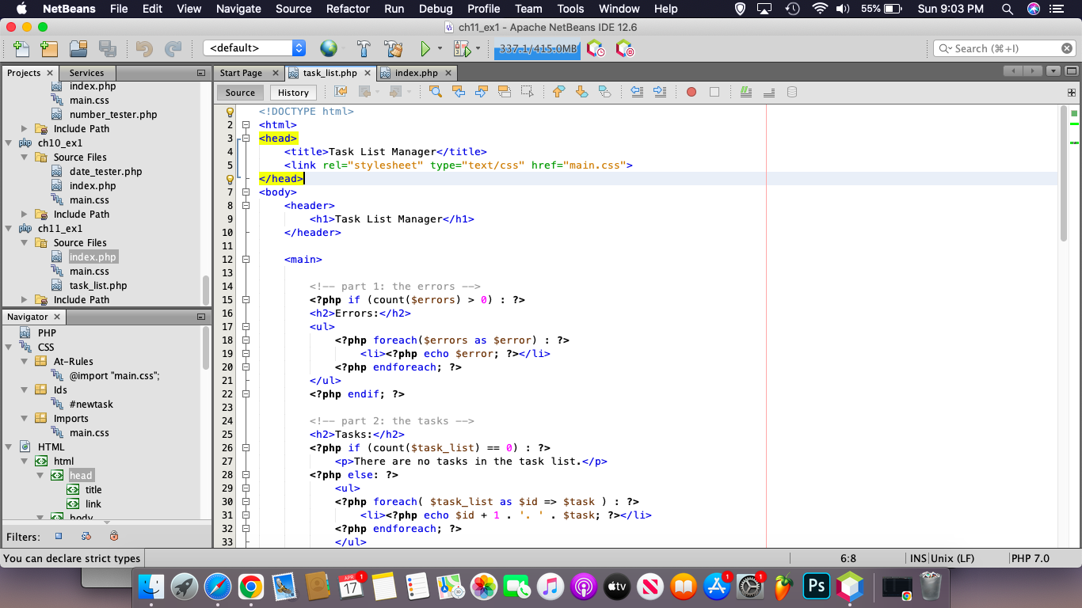Graphical user interface, text, application

   Description automatically generated
4. In the task list. PHP file, just inside the <main> tag, add the following code.A screenshot of a computer

   Description automatically generated
5. Save your changes and run the application. You should see the indexes and values for the task list array in the browser. Graphical user interface

   Description automatically generated
6. Modify the code for adding a task so it uses the array push function to add a new task to the end of the task list array.A screenshot of a computer

   Description automatically generated with medium confidence
7. Add code that lets the user modify an existing task. If the user clicks on the modify task button, this code should hide the form that contains the modified task button, and it should display the form that's included in the task list dot PHP file.A picture containing text, screenshot, computer, computer

   Description automatically generated
8. Add code that allows the user to promote a task. This code should move the selected task up one index in the array of tasks. If the user selects the first task, those codes should display an error that indicates that you can't promote the first task.Graphical user interface, text, application

   Description automatically generated
9. Add code that lets the user sort all task off alphabetically. In addition, modify the code so the sort button is displayed only if the task list contains two or more tasks.A screenshot of a computer

   Description automatically generatedGraphical user interface, text

   Description automatically generated

1. Test your changes.Graphical user interface, application

   Description automatically generated